Why does an overdetermination of the model going into SINDy break it?

“Insufficient rank”

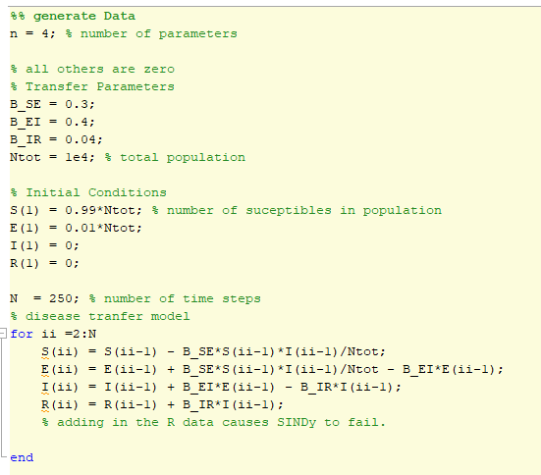

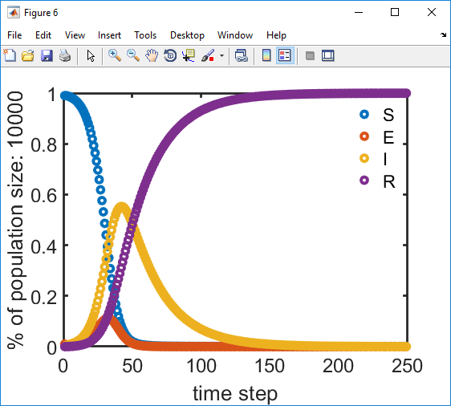

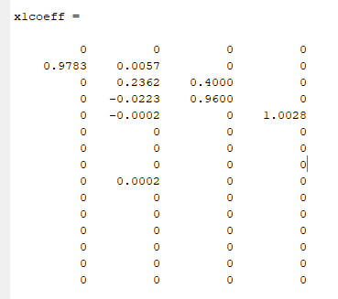

<https://institutefordiseasemodeling.github.io/Documentation/general/model-seir.html>

SEIR with vital dynamics

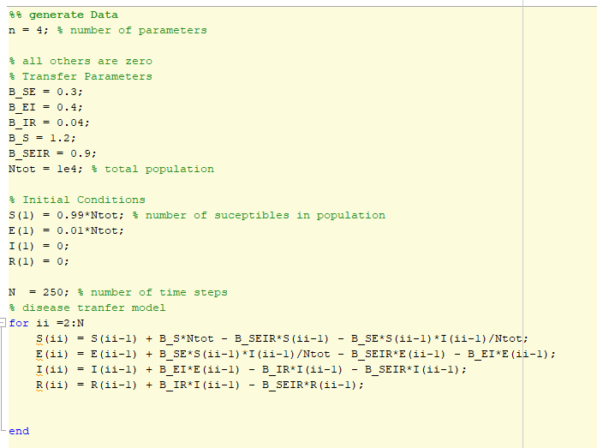

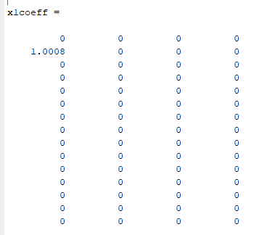

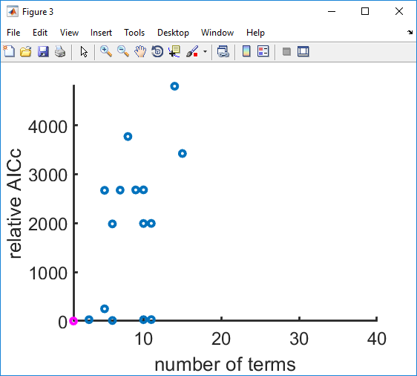

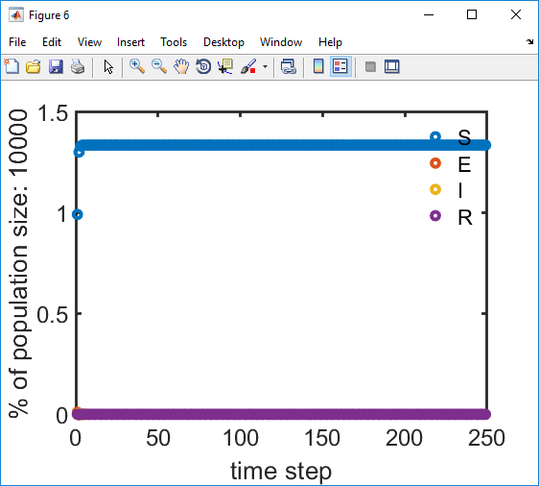

There are 4 ODEs and 5 parameters: is this solvable? - yes

Putting n = 5 breaks the code.

Try again with different birth and death rates:

Mistake: didn't update Ntot for each time step (goes into S and E calculations)

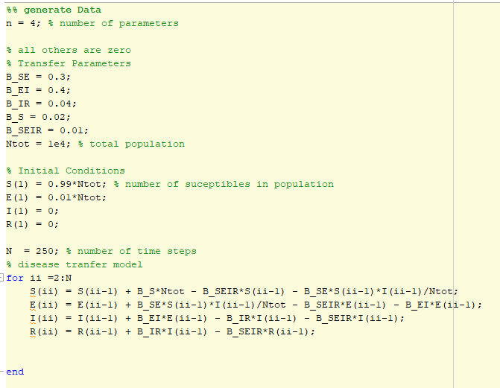

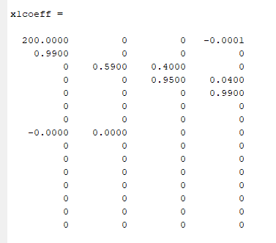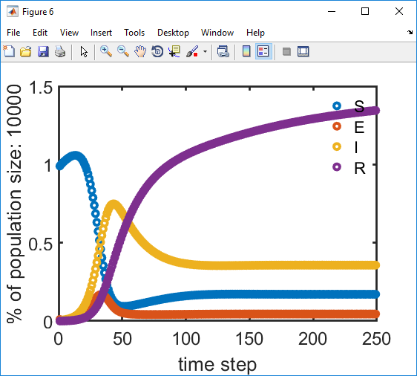

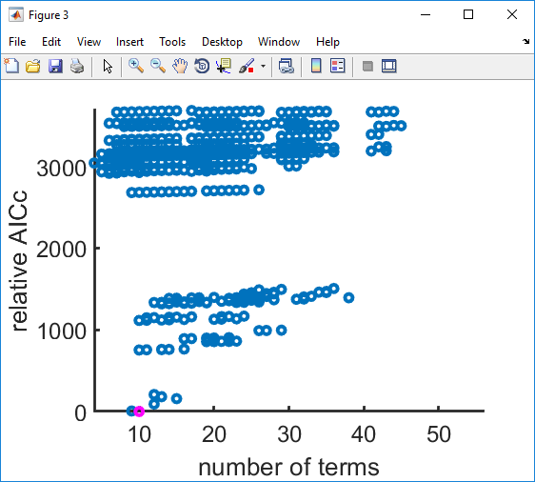

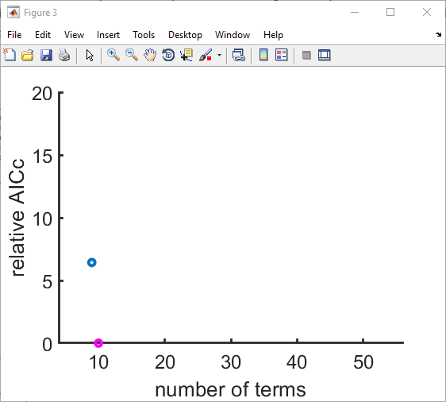

^ How’d it do?

[number of parameters n=4 is actually number of ODE equations?]

**SEIRS model, no vital dynamics**

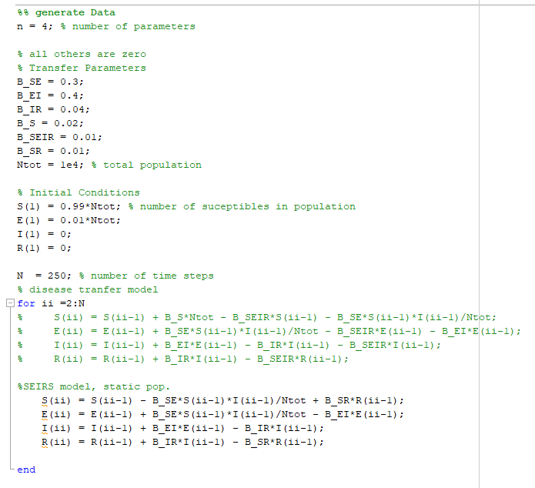

Warning: model rank deficient

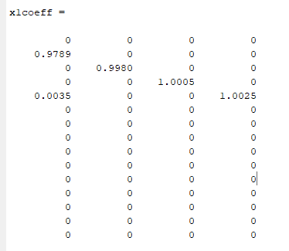

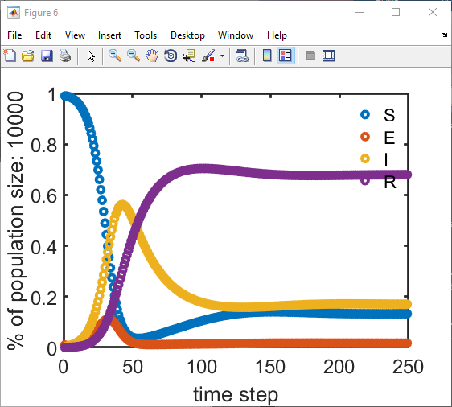

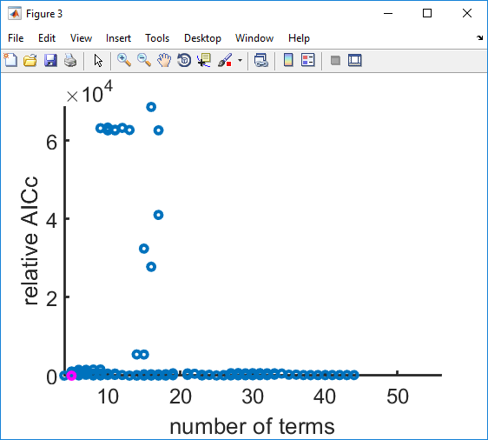

>> figure(3); hold on

>> axis([min(numcoeff) max(numcoeff) 0 10])

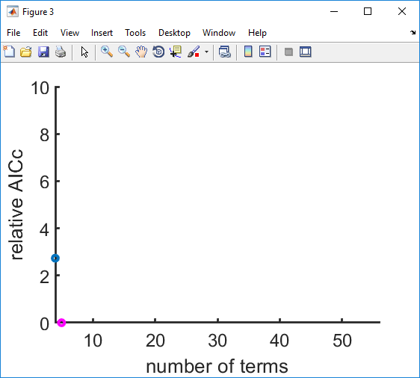

Again. SEIRS, this time without R

(R breaks it because it is overdetermined?)

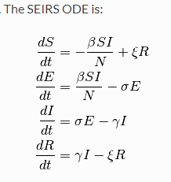

(From IDM model overview page linked above)